**Ng Hoi Yee**

**Final Report:**

✨ Predictive Analysis of Heart Disease Using Machine Learning

**GitHub Repository**: <https://github.com/nhoiyee/Predictive-Analysis-of-Heart-Disease-Using-Machine-Learning->

**Web Application Link**: <https://fbx6xvrqumnjcpi7jqq4mj.streamlit.app/>

**📌Objective**

The objective of this project is to develop a machine learning model capable of predicting the risk of heart disease in patients using the

Heart Disease UCI dataset on Kaggle

(<https://www.kaggle.com/datasets/mragpavank/heart-diseaseuci>).

Key features include age, sex, blood pressure, cholesterol levels, fasting blood sugar, maximum heart rate achieved, exercise-induced angina, and ST depression (oldpeak). The target variable indicates the presence or absence of heart disease.

**🧭 Summary of the steps**

**Feature Engineering**  
The model was trained on eight primary features without additional engineered variables.

['age' 'sex' 'trestbps' 'chol' 'fbs' 'thalach' 'exang' 'oldpeak']

**Model Training**  
A Random Forest classifier was selected for its robustness and ability to handle mixed data types effectively. The dataset was split into a training set (70%) and a test set (30%), to evaluate model performance on unseen data.

The model achieved good accuracy on the test set, demonstrating its capability to classify patients into heart disease positive or negative groups based on the selected features.

**Deployment**

application was developed and deloyed using Streamlit. The app allows users to input patient medical details through an intuitive interface and receive real-time predictions of heart disease risk.

The app was deployed on Streamlit Community Cloud, providing an easy-to-access URL for public use without requiring local installations.

Below are example screenshots of the app interface and prediction output:

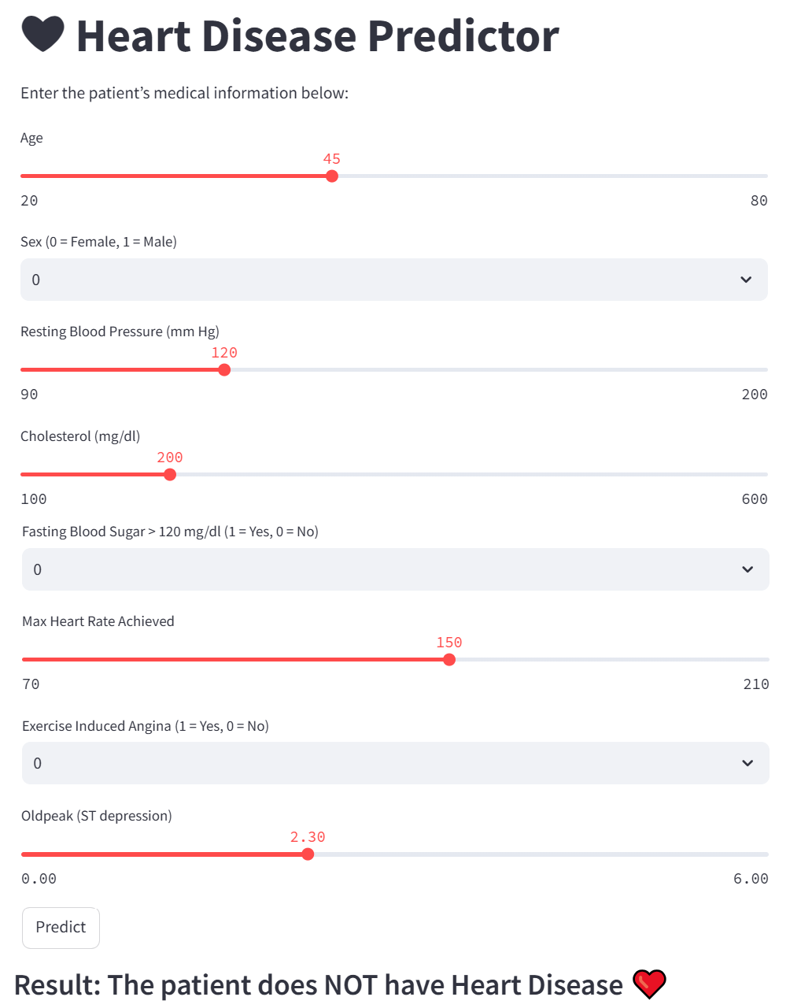

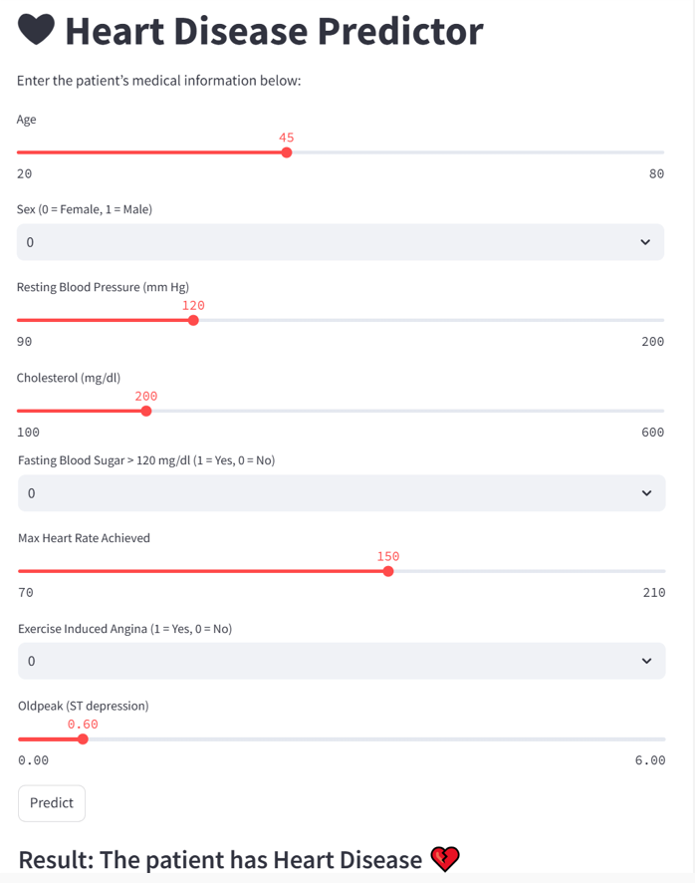

**🧗 Conclusions**

● This project demonstrates a practical approach to heart disease risk prediction using machine learning and web deployment. The Random Forest model, trained on key medical features, provides reliable predictions that can assist healthcare providers and patients.

## 🎖 References

* UCI Machine Learning Repository: Heart Disease Dataset
* Scikit-learn Documentation: https://scikit-learn.org
* Streamlit Documentation: https://docs.streamlit.io